Docker Task -2
Task Description:
Create a dockerfile, docker-compose file which when executed must display your basic details in the website.
Techstacks needs to be used :
- AWS EC2
- Docker

AWS EC2:
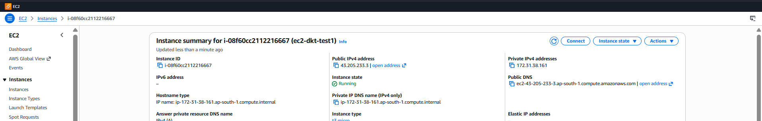
Connection EC2 putty:
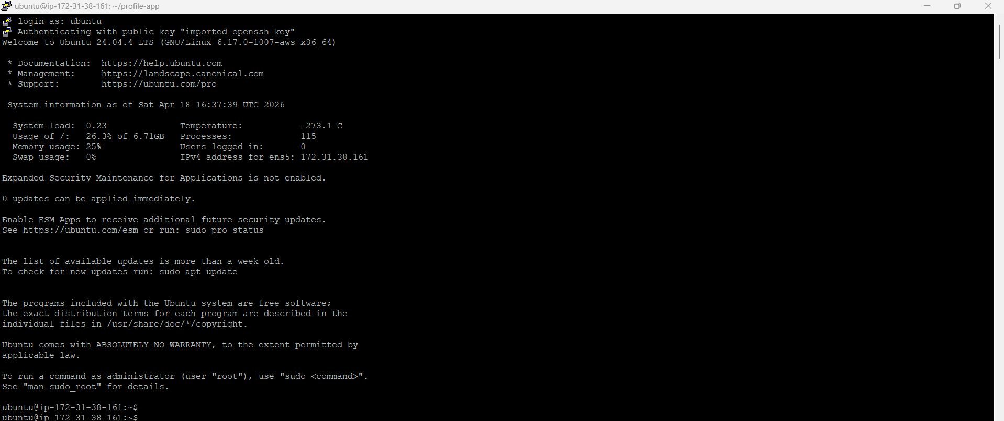
Content update:
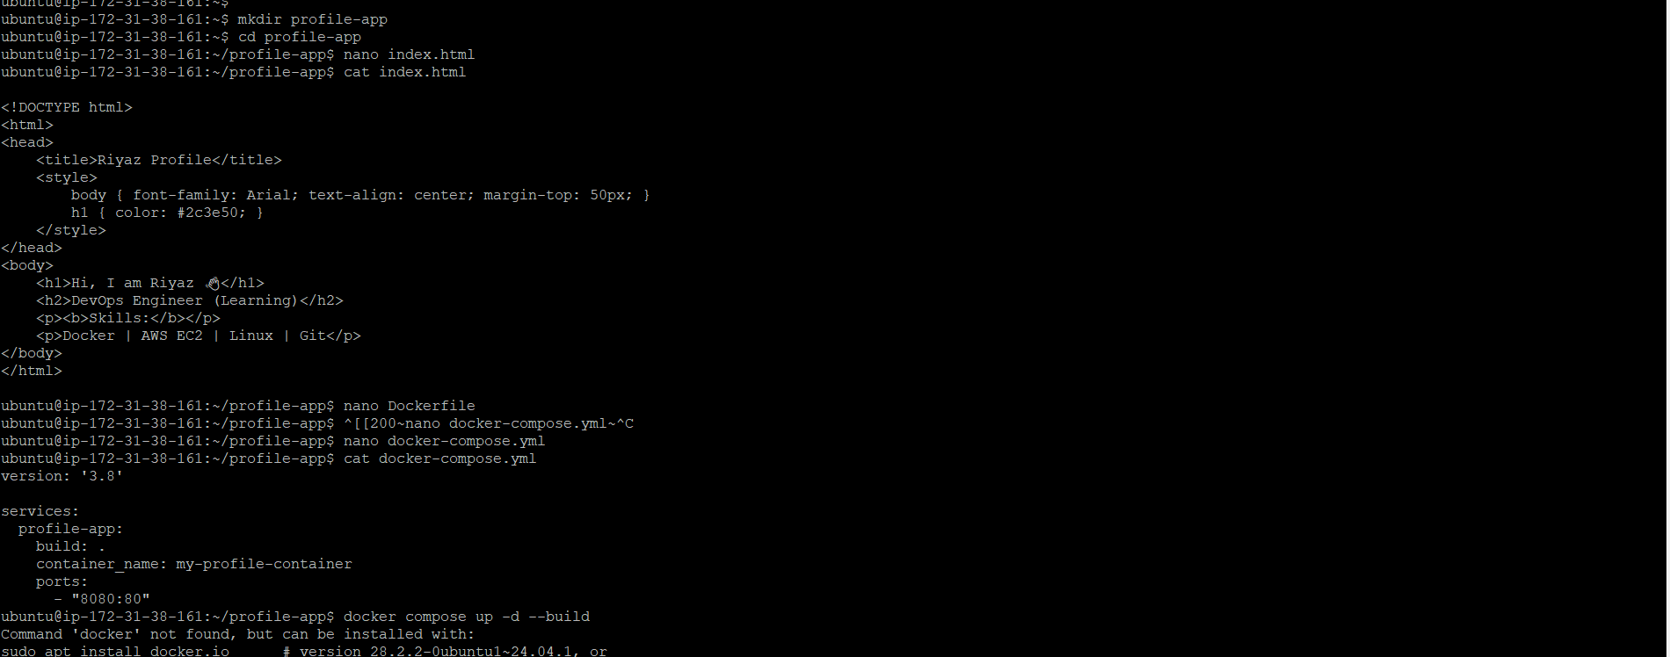

Docker Compose File:
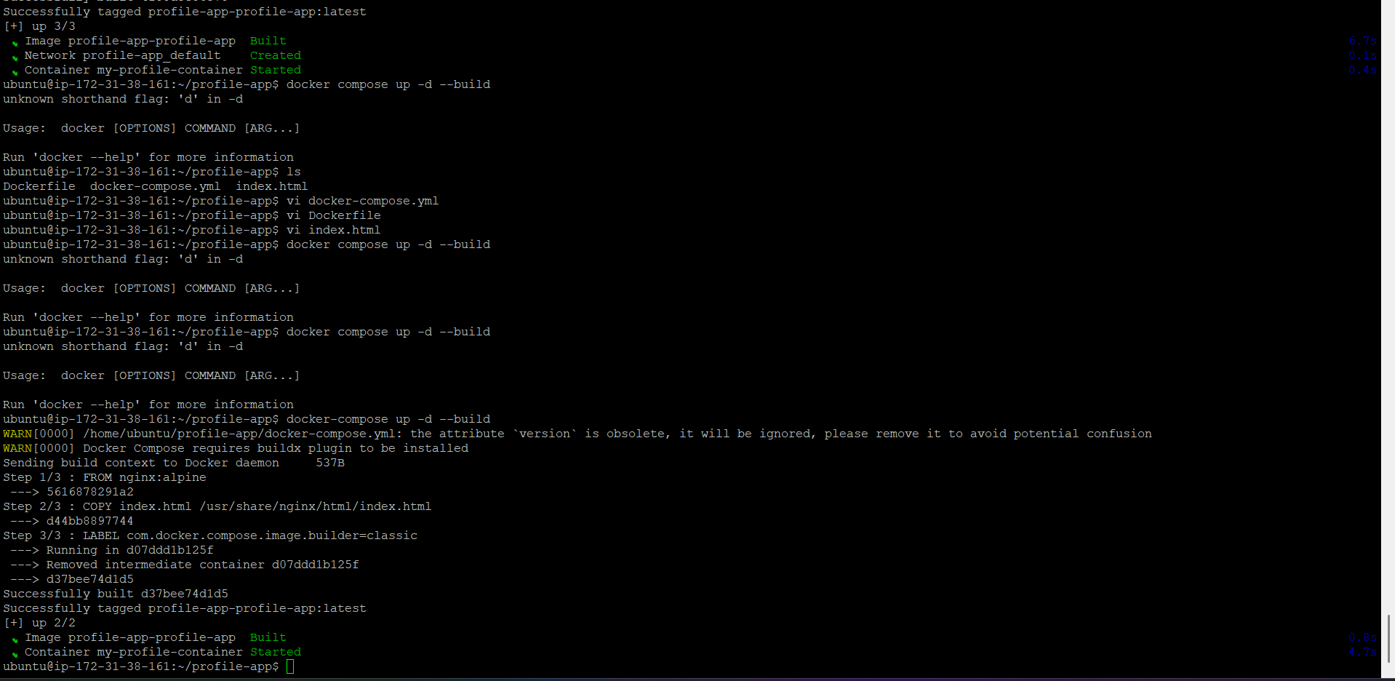
Public IP :8080
